

**ONLINE SERVICE MARKET**

By

**Ashik Bhuiyan**

**(183-35-2585)**

A course project (SE 212: SW Requirements Specification and Analysis) submitted in fulfillment of the requirement for the degree of Bachelor of Science in Software Engineering.

**Department of Software Engineering**

**DAFFODIL INTERNATIONAL UNIVERSITY**

Fall – 2019

**Copyright © 2019 by Daffodil International University**

**DECLARATION**

It hereby declared that this course project title on **“Online Service Market”** under the supervision of **Dr. Md. Asraf Ali, Associate Professor, Department of Software Engineering, Daffodil International University.** It is also declared that neither this project nor any part of this has been submitted elsewhere for award or any degree.

**Student:**

Name: Ashik Bhuiyan

**I**D: 183-35-2585

Batch: 27th

Department of Software Engineering

Faculty of Science & Information Technology

Daffodil International University.

**Certified by:**

Ms. Syeda Sumbul Hossain  
Lecturer (Senior Scale)

Department of Software Engineering

Faculty of Science & Information Technology

Daffodil International University.

**ACKNOWLEDGEMENT**

First of all, I am grateful to The Almighty God for giving me the ability to complete this project. Today I am felling proud for myself. Because, to be a student of Daffodil International University. And I am thankful to Daffodil International University for giving me a chance to give me a chance to prove myself by showing this project. I thank to our Department Head **Dr. Touhid Bhuiyan**. And I want to thank to our respected class teacher Ms. Syeda Sumbul Hossainfor supporting and given your guideline and valuable advices.

Online Service Market is not a new system. But this software will give you better experience. I hope every people who will use this system will be happy after completing their transaction.

To build this software I have collected many types of information about online service and it’s market. And also my friends helped me to build this software. At last I also thank my parents for their unceasing encouragement and support. On record, my sense of gratitude to one and all who, directly or indirectly, have lent their helping hand in this project.

Thank You

Ashik Bhuiyan

**TABLE OF CONTENT**

DECLARATION..........................................................................................................2

ACKNOWLEDGEMENT..............................................................................................3

TABLE OF CONTENT .................................................................................................4

ABSTRACT…………………………………………………………………………………………………………….6

CHAPTER 1: INTRODUCTION………………………………………………………………………………...7

1.1: Background.................................................................................................7

1.2:Motivation of the Project ...........................................................................7

1.3: Problem Statement ...................................................................................8

1.4:Project Objective ........................................................................................8

1.5:Project Organization ...................................................................................8

CHAPTER 2: LITERATURE REVIEW ..........................................................................10

2.1:Existing Project: .........................................................................................10

CHAPTER 3: METHODOLOGY .................................................................................11

3.1: Sign Up………………………………………………………………………………………………….11

3.2: Sign In……………………………………………………………………………………………………11

3.3: Main Menu……………………………………………………………………………………………11

3.3.1: Get Services…..……………………………………………………………………..12

3.3.2: Sign Out………………………………………………………………………………..12

3.4: Exit………………………………………………………………………………………………………..12

CHAPTER 4: RESULTS AND DISCUSSION .................................................................13

4.1: Sign Up………………………………………………………………………………………………13

4.2: Sign In………………………………………………………………………………………………..14

4.3: Main Menu………………………………………………………………………………………..15

4.4: Get Services.………………………………………………………………………………………16

CHAPTER 5: CONCLUSIONS AND RECOMMENDATIONS ........................................17

5.1 Findings and Contributions ....................................................................17

5.2 Recommendations for Future Works ....................................................17

APPENDIX – A……………………………………………………………………..……………………………..18

APPENDIX – B……………………………………………………………………………………………..……..19

APPENDIX – C…………………………………………………………………………………………..………..21

APPENDIX – D…………………………………………………………………………………………..………..23

APPENDIX – E……………………………………………………………………………………………………..26

APPENDIX – F………………………………………………………………………………………………..……28

APPENDIX – G………………………………………………………..…………………………………………..68

**ABSTRACT**

This is a project documentation on “Online Service Management”. During the making of this project I explored new ideas and functionality. This report reflects my steps taken at various levels of programming skills.

This Project will provide any type of online service. This is a C project which helps to take regular services by online. The user have to log in with username and password. Without log in user can’t enter.

The main objectives of this project is to build a Software for online service market management easy and within short time. User can buy services and see total bill. User can easily calculate total bill of selling.

We can use this software for making easy of all type of service management system and there is no waste of time.

**CHAPTER 1: INTRODUCTION**

* 1. **Background**

In this 21st century, we are living in information era. Day by day information is increasing in all sectors, but ability to store them proper way and make proper use of that information does not growth. By definition, online service market management system is a system where user can store all information and manage all part of service or bill.

* 1. **Motivation of the Project**

The motivation for designing this system because I was curious about whole ticket management system of a online service market. I saw maximum markets whole system wasn’t computerized. That’s why I explored some ideas and thought about how to make management system of an existing market is computerized. Then I have learnt a lot of things of ticket management system of a service market and implement this system.

* 1. **Problem Statement**

Now in this world there are so many online service market. Manager cannot keep their information in safe and many of them lose their information. When they need any kind of information about their tickets they cannot find information easily and there is a lots of waste of time to find the information.

* 1. **Project Objective**

For solving park manager’s issue I come in a decision to make a market management system where managers are relax about their service information and they will easily store their information into the system. I can confidently say that by using this system they are 100% safe and secure. They are not going to afraid of losing their information. They can easily find out a service what he need. I think this is the easiest system to store their all kind of information.

* 1. **Project Organization**

In first chapter I discussed background of my project. Here I also discuss motivation of the project, project description, problem statement and problem solution.

In Second chapter I mainly discussed its methodology that how it works with many things that I used to manage the program.

In Third chapter I mainly discussed its result and discussion or OUTCOME. With what to press to do what. All of this are done with screenshots of the project required part.

In last chapter of fourth chapter I discussed about future plan or Recommendations. That what is my future plan with this software. What a want to add this in future. And at present what can I do with this project.

**CHAPTER 2 : LITERATURE REVIEW**

**2.1 Existing Project:**

There are so many project about service management system. I saw some of them but I wasn’t full of satisfied. Some project has a little things to do. Lots of things can be added with that. Then it will be more user friendly and helpful to manage any service.

I have tried to this project user friendly to the user. I added many things more than previous existing project. By using this system user may can be satisfied. I mainly focused on energy saving and how to avoid waste of time.

**CHAPTER 3: METHODOLOGY**

At first needed to be sign up first. After successfully signed up user can sign in and do all the things of this system.

**3.1 : SIGN UP**

When someone is using this system for the first time, he/she needs to sign up first.

**3.2 : SIGN IN**

After signing in with the correct username and password, user can access the system.

**3.3 : MAIN MENU**

After successfully signed in, there will be some options to choose. Main menu has some options. Each options contains the primary type of the services. Then you can choose your service by selecting any type.

**3.3.1 : GET SERVICES**

In this option, you will see the name of the available services of the market. You can choose your service you want. After choosing one, another window will open and you will be asked the quantity.

It will show you the total amount of money. Thus, the process of buying services completes.

**3.3.2 : SIGN OUT**

Once you choose this option, you will get out of the system. To access again you need to sign in again the system.

**3.4 : Exit**

If user chooses this option, the program will end and will close the whole system within two seconds.

**CHAPTER 4 : RESULTS AND DISCUSSION**

**4.1 : SIGN UP**

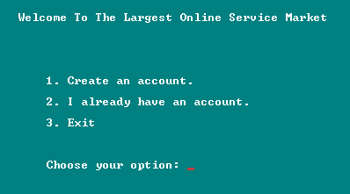

If you are using this system for first time, you need to create an account first. Then you can choose 1 for sign up.

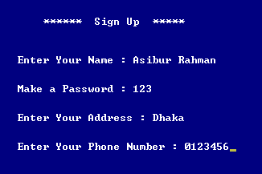

Here, the system will ask you your name, password, address and phone number. After that, you are successfully signed up. Now, pressing any key will take you for sign in.

But if you give any username which is already taken or the name is already registered, then it will show you that, you can’t use this name. You need to use another name to register.

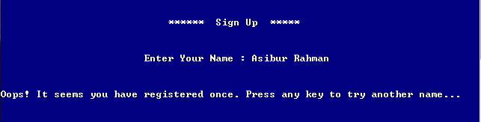

**4.2 : SIGN IN**

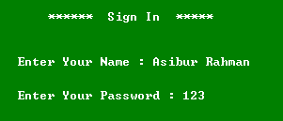

In this way, you have to give your given name and password. But if you give wrong user name and password, then it will not sign you up there.

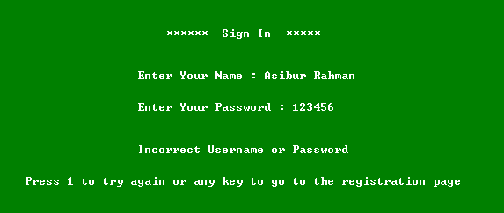

It will repeatedly ask you for the correct username and password till it is correct.

**4.3 : MAIN MENU**

Here, you will be shown the following options :

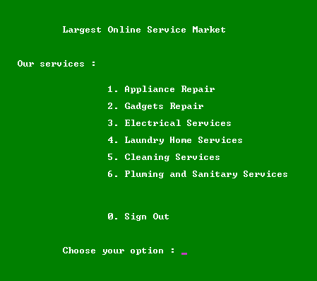

**4.4 : GET SERVICES**

This option will show you the name of the Services. You can choose any of them.

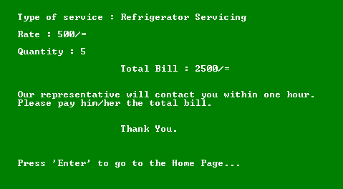

Then it will show you the total bill and you will be contacted with your given phone number and address.

**CHAPTER 5: CONCLUSIONS AND RECOMMENDATIONS**

**5.1 Findings and Contributions**

After completing the project, we can easily do this :

* Sign Up to a system
* Sign un to a system
* Get various types of services
* See the total sales.

**5.2 Recommendations for Future Works**

This software have a nice future plan. This is possible to make more useful system with this software. My future plan about this software is work with accounting option that can helps to observation markets fund. Manager or owner can utilize their profit or loss.

* **SW Requirement**

1. Functional

2. Non-Functional

1. Authentication user
   1. Registration user
   2. Login user
2. MAIN MENU
   1. Appliance Repair
      * 1. AC Repair
        2. IPS Servicing
        3. TV Servicing
        4. Generator Servicing
   2. Gadgets Repair
      * 1. Desktop Servicing
        2. Laptop Servicing
        3. Smartphone Servicing
   3. Electrical Services
      * 1. Fun Service
        2. Tube light Service
        3. Pump Service
3. Search items
4. Chose Services Name
5. Services Rate
6. Quantity
7. Total Bill
8. Pay Bill
9. Confirm Reservation
10. Cancel Reservation
11. Again Check Main Manu
12. See the total sales.